INTERNSHIP REPORT
ON
GRAPHIC DESIGNING FOR SOCIAL AWARENESS
Submitted
To
School of Computer Science and Engineering
IILM University, Greater Noida, U.P.
In partial fulfilment of the requirement of degree of
B.Tech CSE

By
Devanshi rajvanshi
Roll Number: 25SCS1003000905
Batch: 2026-27
Organization: Relief Mission Foundation
Internship Role: Graphic Designer Intern
Internship Period: 01 August 2026 – 31 August 2026

CANDIDATE’S DECLARATION
I, DEVANSHI RAJVANSHI, hereby declare that the internship report titled “Graphic Designing for Social Awareness” has been completed by me to fulfil the requirement for the award of the degree of Bachelor of Technology in CSE. The report presents the work and learning associated with my one-month virtual internship as a Graphic Designer Intern at Relief Mission Foundation.
I affirm that the work presented in this report is prepared for academic submission and that references and supporting material have been acknowledged wherever applicable. I further declare that this report has not been submitted to any other institute for any degree or diploma requirement.

Signature: ______________________________
Student Name: DEVANSHI RAJVANSHI
Roll No.: 25SCS1003000905

ACKNOWLEDGEMENT
I am grateful to Relief Mission Foundation for providing me the opportunity to undertake a one-month virtual internship as a Graphic Designer Intern. The internship gave me practical exposure to creating digital communication material for social-awareness campaigns and helped me understand how visual design can support community-oriented initiatives.
I sincerely thank the organization and its team for their guidance, feedback and encouragement during the internship. Their inputs helped me improve my understanding of composition, typography, colour selection, visual hierarchy and message clarity.
I also express my gratitude to my university, faculty members, and my parents for their continuous support and encouragement throughout this internship and while preparing this report.

Signature: ______________________________
Student Name: DEVANSHI RAJVANSHI
Roll No.: 25SCS1003000905

INTERNSHIP COMPLETION CERTIFICATE
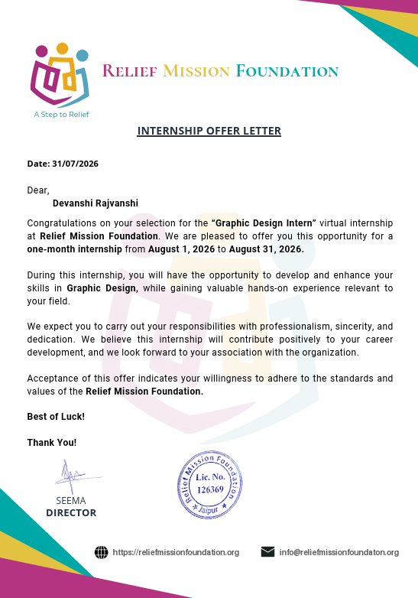
TABLE OF CONTENTS
Chapter | Chapter Name | Page No.
1. | Candidate’s Declaration | I
2. | Acknowledgement | Ii
3. | Internship Completion Certificate | Iii
4. | Project Description | 1
4.1 | Introduction | 1
4.2 | Organization Profile | 2
4.3 | Problem Statement | 2
4.4 | Project Objectives | 3
4.5 | Scope of the Project | 3
4.6 | Technologies and Tools Used | 4
4.7 | System Architecture / Creative Workflow | 5
4.8 | Methodology | 6
4.9 | Expected Outcomes and Learning | 7
4.10 | Certificates and Communication Proof | 8
5. | Bibliography / References | 9

CHAPTER 4
PROJECT DESCRIPTION

4.1 Introduction
The internship project focused on graphic designing for social-awareness communication at Relief Mission Foundation. The internship offer letter identifies the role as a “Graphic Designer Intern” and describes the opportunity as a one-month virtual internship from 01 August 2026 to 31 August 2026.
The main purpose of the project was to transform social messages into clear, attractive and easy-to-understand digital creatives suitable for awareness campaigns. The work involved developing poster concepts, selecting suitable visual elements, arranging text and imagery, and maintaining consistency in branding and communication.
The internship provided practical exposure to the design process from understanding a brief to preparing a final social-media-ready creative. It also highlighted the importance of empathy, simplicity and responsible visual communication when designing for social causes.

4.2 Organization Profile
Relief Mission Foundation is the organization associated with this internship. The supplied offer letter identifies the organization as Relief Mission Foundation and carries the tagline “A Step to Relief.” It also identifies Seema as Director.
The organization’s communication material is focused on relief and social-impact activities. Within the internship, the design work was oriented toward awareness-oriented messages that encourage responsible social behaviour and support for underserved communities.
Organization website: https://reliefmissionfoundation.org
Internship contact shown on the supplied offer letter: info@reliefmissionfoundaton.org

4.3 Problem Statement
Social-awareness campaigns often contain important messages but may fail to attract attention when the information is crowded, visually inconsistent or difficult to understand. The project therefore addressed the need to create simple and engaging digital graphics that communicate one clear social message at a time.
The design challenge was to balance emotional impact with readability and responsible representation of social issues. Each creative needed an appropriate headline, supporting message, imagery, typography and visual hierarchy while remaining suitable for digital sharing.

4.4 Project Objectives
- To understand and apply the basic principles of graphic design in a practical internship environment.
- To create digital awareness creatives for social and community-focused themes.
- To improve skills in typography, colour selection, composition, spacing and visual hierarchy.
- To communicate social messages clearly using limited but meaningful text.
- To develop consistency across multiple campaign creatives while allowing each poster to have its own visual identity.
- To receive feedback and refine designs before final presentation.

4.5 Scope of the Project
The project scope covered the conceptualisation and design of social-awareness posts for digital platforms. The work included understanding campaign briefs, preparing layouts, selecting or arranging suitable visual elements, creating headline-supporting text, and refining designs for clarity and presentation.
The awareness themes addressed during the internship included responsible giving and reuse, access to educational resources, volunteering and community service, elderly care and support, and clean water and water conservation. These themes were approached through concise awareness messages and visually focused poster layouts.
The scope did not include software development, website programming, paid advertising management, printing production management, or measurement of long-term campaign performance.

4.6 Technologies and Tools Used
The internship primarily involved digital graphic-design work. The following tools and technologies represent the practical design workflow used for creating and refining the awareness creatives.
Tool / Technology | Purpose
Graphic design software | Creating layouts, arranging elements, editing graphics and preparing final poster designs.
Typography tools | Selecting typefaces, adjusting font sizes, weights, spacing and hierarchy.
Colour tools | Selecting complementary colour combinations and maintaining visual consistency.
Image resources | Using appropriate photographic or visual elements to support the social message.
Digital export formats | Preparing final creatives in commonly used image formats suitable for social-media sharing.
The exact software package used for individual design tasks may vary by workflow. The important practical skills developed during the internship were design composition, visual hierarchy, digital editing, consistency and presentation.

4.7 System Architecture / Creative Workflow
Because this was a graphic-design internship rather than a software-development project, the “system architecture” can be represented as a creative production workflow. The workflow moved from the campaign brief to the final digital creative.
Stage | Input | Process | Output
1. Brief Understanding | Campaign topic and objective | Identify audience, purpose and key message | Design direction
2. Concept Development | Key message | Generate headline, supporting line and visual concept | Initial concept
3. Visual Composition | Images, logo, text and colour palette | Arrange elements using hierarchy, balance and spacing | Draft layout
4. Design Refinement | Draft feedback | Adjust typography, alignment, contrast and visual emphasis | Revised creative
5. Finalisation | Approved layout | Check readability, branding and overall consistency | Final digital poster
6. Delivery | Final creative | Export and organise the design for submission/sharing | Campaign-ready asset

4.8 Methodology
A brief-driven iterative methodology was followed throughout the internship. Each assignment began with understanding the topic and the desired social message. The content was then reduced to a concise headline and supporting statement so that the main idea could be understood quickly.
- Analyse the campaign brief and identify the central social message.
- Define the target audience and the emotional or informational tone required.
- Prepare a basic layout with a clear focal point.
- Select typography that remains readable on a digital screen.
- Choose a colour theme that supports the subject and creates visual contrast.
- Place imagery so that it supports rather than competes with the message.
- Apply consistent branding and spacing across the creative.
- Review the design for readability, balance, alignment and unnecessary visual clutter.
- Refine the design based on feedback and prepare the final version.

Design Principles Applied
- Visual hierarchy – making the main headline the first point of attention.
- Contrast – separating text and important elements from the background.
- Alignment – maintaining clean relationships between text, images and branding.
- Balance – distributing visual weight so that the poster feels stable.
- Consistency – using repeatable typography, spacing and branding conventions.
- Simplicity – avoiding excessive text or decorative elements that weaken the message.

4.9 Expected Outcomes and Learning
The internship was expected to strengthen both technical design skills and professional working habits. The project-based approach provided an opportunity to practise converting a written social message into an effective visual communication piece.
Area | Learning Outcome
Graphic design | Improved understanding of composition, hierarchy, balance and spacing.
Typography | Better selection and arrangement of headings, supporting text and emphasis.
Colour | Improved ability to build readable and topic-appropriate colour palettes.
Communication | Greater focus on communicating one clear message through limited text.
Creative thinking | Ability to develop different visual treatments for related campaign topics.
Professional practice | Experience in working from briefs, refining drafts and preparing final deliverables.

Campaign Design Work
The internship design work covered multiple social-awareness themes. Each theme required a different visual treatment while retaining a clear, accessible communication style.
Responsible Giving & Reuse: Encouraged people to donate gently used and useful items instead of discarding them, connecting surplus possessions with community needs.
Access to Educational Resources: Highlighted how books, stationery and learning resources can improve educational opportunities for children from underserved communities.
Volunteering & Community Service: Communicated that people can contribute through their time, skills and energy, not only through financial donations.
Elderly Care & Social Support: Focused on respect, companionship and support for older people, using a sensitive and dignified communication approach.
Clean Water & Water Conservation: Raised awareness about the importance of clean water, healthy communities and responsible water use.

Challenges Faced and Solutions
Challenge | Approach Used
Fitting the message into a limited poster area | Reduced unnecessary words and strengthened headline hierarchy.
Maintaining readability over imagery | Used contrast, spacing and controlled placement of text.
Avoiding repetitive designs | Changed composition, colour treatment and visual emphasis across campaigns.
Representing social issues respectfully | Used dignified visual communication and avoided excessive visual clutter.
Maintaining a consistent identity | Kept branding and core layout discipline consistent while varying campaign-specific elements.

Professional Development
The internship helped connect classroom knowledge with practical visual communication. It encouraged attention to detail, iterative improvement and deadline-oriented work. It also demonstrated that effective social design is not only about making a poster attractive; it is about making the intended message understandable, memorable and appropriate for its audience.

4.10 Certificates of Completion and Communication Proof
The supplied documentation includes an Internship Offer Letter dated 31 July 2026. It confirms Devanshi rajvanshi’s selection for the Graphic Designer Intern virtual internship at Relief Mission Foundation for one month from 01 August 2026 to 31 August 2026.
The offer letter also states that the internship would provide an opportunity to develop and enhance Graphic Designer skills while gaining relevant hands-on experience, and it requests professionalism, sincerity and dedication.
For final university submission, the official Internship Completion Certificate and any relevant communication/email proof should be inserted here if they are issued or available. The offer letter is attached below as the available supporting document.



5. BIBLIOGRAPHY / REFERENCES
Relief Mission Foundation. Internship Offer Letter, dated 31 July 2026. Supplied internship document.
IILM University, School of Computer Science and Engineering. Internship Report Format updated 26-27. Supplied academic report template.
Relief Mission Foundation. Official website: https://reliefmissionfoundation.org (organization information as referenced in the supplied offer letter).

